**Mobile hand set application architecture**

This spring boot application calls the Json URL(https://api.myjson.com/bins/1f2r2v?pretty=true) internally using Rest GET endpoint and then render the json array response, filter them by given search criteria. To run application, you can follow README file instruction.

Project files hierarchy:

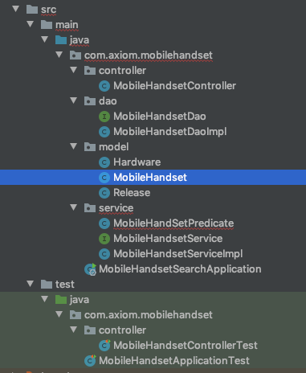

MobileHandsetController

The Rest Controller with one Get method to fetch all or filtered data from URL.

MobileHandsetController injects service layer and returns HTTP ok response with the data, otherwise internal server error if something goes wrong in below layers.

MobileHandsetController calls MobileHandsetService where main logic for filtering happens and service gets data from low level layer MobileHandsetDao where there is a call to Json url to get actual data.

,

Model classes schema:

